1
1.4 Texas style blues – vs.5

[Nick head and shoulders]
Intro:
Verse 5 – more bending technique
[Cut to Nick Plus Guitar]
Cue BTrack
Demo Texas Blues Verse 5

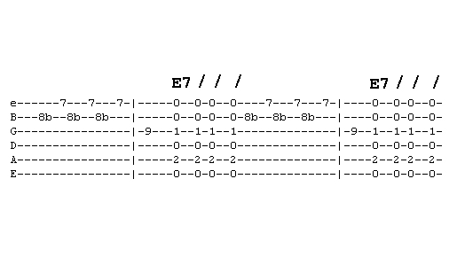
First look at tab for first phrase
[Cut to 16to9_tabTexBlues_16.jpg]

We see ‘b’ for ‘bend’ on the note 8th fret B string
[Cut to left hand with 16to9_tabTexBlues_16.jpg as PIP]
This is followed by fret 7 on the top E
Demo
The phrase resolves to the E note fret 9 on G string
2
Demo
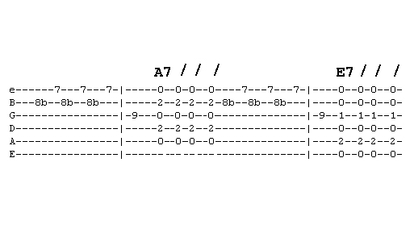
[Cut to 16to9_tabTexBlues_17.jpg]

The second line is exactly the same lead lick resolving on the same E note. But followed by the A7 chord
[Cut to left hand with 16to9_tabTexBlues_17.jpg as PIP]
Demo
This shows that licks don’t always resolve on root notes
There’s an E note in the A7 chord
Demo
The last line has one simple change to the lead
[Cut to 16to9_tabTexBlues_18.jpg as PIP]

The phrase lands on the B note on the D string at fret 9

3
[Cut to left hand with 16to9_tabTexBlues_18.jpg as PIP]
Demo
You can hear that this change fits the B chord
The B chord doesn’t contain the note E
Demo

[Cut to Nick plus guitar]
Now we’re ready to play the whole verse

Demo with whole verse played faintly

Now you have learnt first five verses try putting it all together yourself
Here’s the backing track. I’ll play through with you on the first run through then leave you to it.
Cue Backing Track
Have fun with that and once you have got it down come back for the final verse six ================================================================

