1
2.3 Guitar Gym - Induction

[Nick head and shoulders]

We are going to work on the Easy Warm-up exercise - great for getting your hands warmed up and developing fluency and speed on guitar.

As you go through this lesson we’ll be talking about all kinds of stuff that applies to all the exercises in the Guitar Gym part of the site.

We’ll cover how to learn music as quickly and efficiently as possible and how to make the best use of the metronome.

Ok here’s the tab for the exercise. Take a minute or two to familiarise yourself – you’ll soon see it’s a pretty systematic sequence of notes.

2
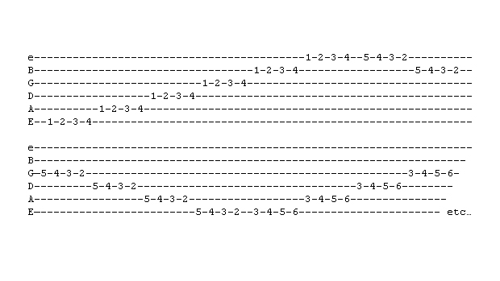
[Cut to 16to9_tabEasyWarmUp.jpg]

The important thing with the left hand is one-finger-per-fret

[Cut to left hand with 16to9_tabEasyWarmUp.jpg as PIP]

Demo

You go straight across from the bottom string to the top then up a fret and back fingering 4 3 2 1

Demo

[Cut to Nick Plus Guitar]

The important thing with the right hand is
To use a consistent picking system.

If you are using a pick try all three of these methods

3
[Cut to right hand with 16to9_tabEasyWarmUp.jpg as PIP]
All down strokes:
Demo
All up strokes:
Demo
Alternating up and down strokes:
Demo

If beginner use the one you find easiest then work at the methods you find hardest. The alternating one is the most important.

[Cut to Nick Plus Guitar]

If you are using fingers there are several methods that are worth developing

Remember we use the letters PIMA to refer to the right hand fingers as follows:

4
[Cut to 16to9_RHfingernames.jpg]
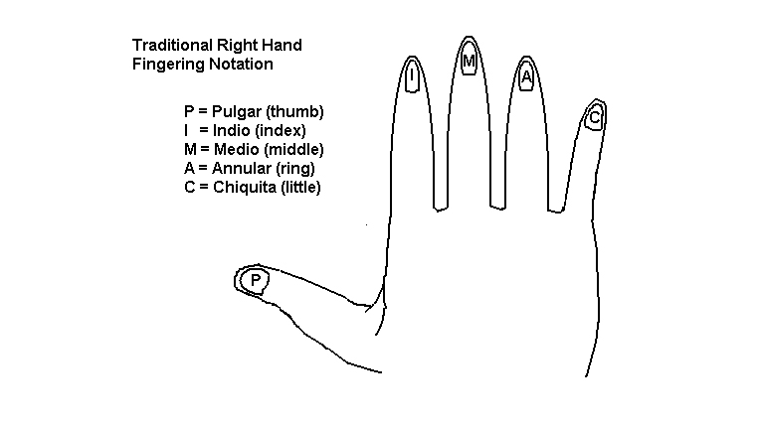

[Cut to right hand with 16to9_RHfingernames.jpg as PIP]

P on 654 and I m a on 321
Demo
P and I alternating throughout
Demo
P IMA throughout
Demo
MI ascending and IM descending
Demo
IM throughout
Demo

[Cut to Nick Plus Guitar]
Now a word about how to learn things quickly on the guitar. Trick is to focus on one aspect of what you are doing at a time in this precise order:

5
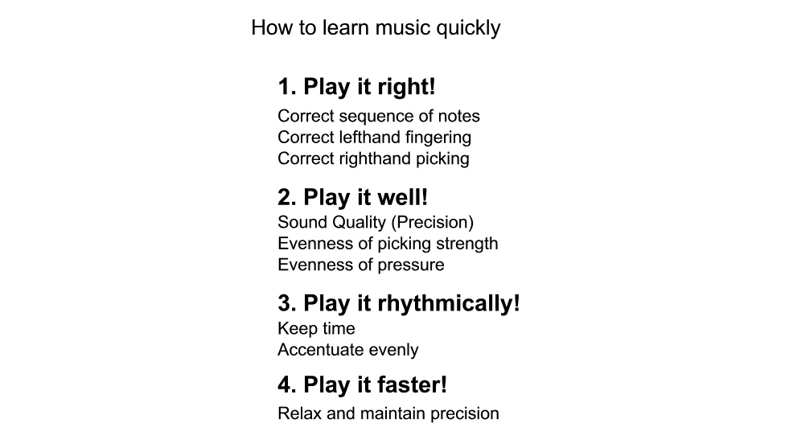
[Cut to 16to9_learnmusicquickly.jpg]

[Cut to Nick Plus Guitar with 16to9_learnmusicquickly.jpg as pip]

Concentrate first on playing it right
Demo
- correct notes
- In the correct sequence
- with the correct left hand fingering and
- correct righthand picking

Then play it well!

[Cut to left hand with 16to9_learnmusicquickly.jpg as pip]
Demo
- Fingers right behind frets
- Evenness of pressure perpendicular

6
[Cut to right hand with 16to9_learnmusicquickly.jpg as pip]
Demo
- Evenness of picking

[Cut to 16to9_learnmusicquickly.jpg]

Only when all these points are in place is it worth worrying about the last two major concerns.

[Cut to Nick Plus Guitar]
When it comes to playing rhythmically and finally playing fast then it is worth using a metronome (toolkit).

To demonstrate in detail how best to use the metronome I’m going to show you using this mechanical one (but everything I say applies to using the online one).

Demo

Firstly I would advise not even starting with the metronome until you can comfortably play at a rate of one note per beat with the metronome set at 80 bpm.
7
If you’re not yet up to this speed you are better off concentrating just on playing right and playing it well.

So let’s say I have spent a while doing just that and have got the exercise I’m working on up to 80 Bpm.

[Cut to metronome as I set it]
Setting the metronome at that speed I start just by playing the first note and listening to make sure I am in time.

[Cut to Nick plus guitar plus metronome]
Demo
Then I take my attention off the metronome and allow my inner sense of rhythm to take over. I let my foot tap or my body sway to the rhythm. Every now and then I check in to see if the metronome is in time with me.

Once I have made this connection I start the exercise relying on my internal sense of time keeping.
8
- Now the wrong way to use a metronome is to chase it like this:
Demo

[Cut to Head and Shoulders]
So once you have completed the exercise successfully at 80pm take it up to 8-10 beats higher. Traditionally metronomes are graduated in divisions of 4 or 8 beats.
So I take mine up to 88 bpm and repeat:

[Cut to Nick plus guitar plus metronome]
Demo
First just on the first note… then on the whole exercise.

Now maybe you find this speed really easy. If you are maintaining good quality then by all means jump up more but:

DON’T WASTE TIME PRACTICING PLAYING BADLY!

9
[Cut to Head and Shoulders]

Once you reach twice the speed you started at (in our case 160 bpm) adjust the metronome back to 80 bpm and play two notes to the beat:

[Cut to Nick plus guitar plus metronome]
Demo

This is where you start drilling accentuation.

Again work it up a few bpm at a time maintaining quality all the way until you’re doing 1.5 times (120bpm) then back down to 80 bpm and try 3 notes per beat:

This is a lot harder, but really important training.

Demo

This will really help playing in compound times like 12/8 as used in blues.
10
Finally try 4 notes per beat.
Demo at 80 bpm

Now if you can work that up to 4 notes per beat at 160 bpm – then welcome to shreddersville!

[Cut to Head and Shoulders]

Ok that’s the induction over. Spend a bit of time familiarising yourself with the exercise at whatever speed is appropriate to your experience level. Almost everything we have talked about in this lesson is applicable to all the exercises in the Guitar Gym. So bear these principles in mind when you start out with each exercise.

Have fun! Now I’m off to the steam room and sauna!

================================================================

