1
3.1 Classic Guitar Intros and Riffs – Intro to Smoke on the Water by Deep Purple

[Open with 16to9_BluesScale_11.jpg]
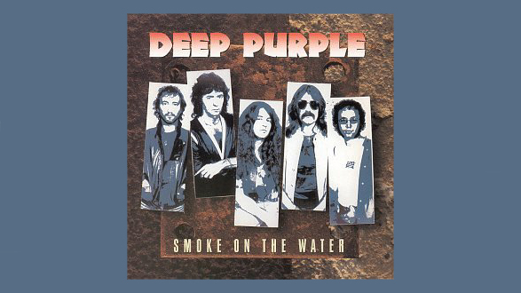

[Attach soundfile: SGT_IntroSmokeOnTheWater.wav]

[Nick head and shoulders]

This must be the most famous electric guitar riff in the world and it’s a great one to start with as it really isn’t hard to play.

First make sure the volume settings on your guitar are turned all the way up and that your amp is set to overdrive or distortion. If you’re not sure how to get these settings then check our Lessons on this on the beginners’ electric guitar course.
2
This is played in normal tuning.

Here’s the Tab
[Cut to 16to9_TabIntroSmokeOnTheWater.jpg]

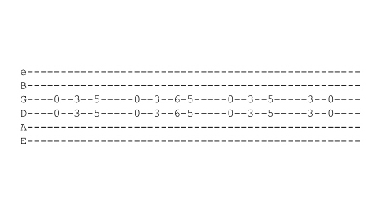
[Cut to RIGHT hand with 16to9_ TabIntroSmokeOnTheWater .jpg as PIP]

First we play the middle two strings open
Demo
Either with the pick or index and middle fingers or thumb and fingers
Demo

[Cut to left hand with 16to9_ TabIntroSmokeOnTheWater .jpg as PIP]

Then with your first finger, fret both the middle strings at the 3rd fret
Demo
And then the same two strings at the 5th fret using your third finger
3
[Cut to Nick Plus Guitar]

Practice that phrase a few times then…

The next phrase starts the same
Demo
But then goes into this quick pair of chords

[Cut to left hand with 16to9_ TabIntroSmokeOnTheWater .jpg as PIP]
Demo

A lot of people are tempted to slide this but actually on the record Ritchie Blackmore plays it as two separate chords
Demo right and wrong

Then the first phrase repeats
Demo
And we finish with just two chords
Demo

4
[Cut to Nick Plus Guitar]

So here’s the whole intro played at slow speed 1 2 3 4…

[Cut to left hand with 16to9_ TabIntroSmokeOnTheWater .jpg as PIP]

Demo at 60bpm
And at full speed – around 112 bpm

Demo at 112bpm

[Cut to Head and Shoulders]

So there you go – that’s one to play to your Dad or Grandad! See you in the next lesson.

================================================================

