123456789101112
4.9 Beginner’s Electric Guitar Course – Intro

[Nick Plus Guitar and zoom in to left hand]
Demo Sunshine of your love

[Nick head and shoulders]
Welcome Secret Guitar Teacher’s
Beginner’s Electric Guitar Course.

This course assumes no prior experience at all and will take you through all the steps necessary to get you to a level of expertise where you can play cool sounding tunes like the one I just played on the opening there.

This intro video is designed just to give you a quick glimpse of what is in store for you on this course.

[Cut to Nick Plus Guitar]
The first couple of lessons are really just to help you get to know your equipment better.
In Lesson 4.2 we show you a neat trick to help you work out which of the controls on your guitar affect which pick-ups.

In Lesson 4.3 – How to play the amplifier – we address a question we know many guitarists want to know the answer to: Exactly How Do I set Up my guitar and amp to get a good sustain sound at reasonable volume: This sound:

[Cut to Amp briefly then pan back to Nick plus guitar]
Demo

It may be you have already figured out what all the knobs and switches on your guitar and amp do then it’s fine to jump straight to the third lesson (4.4) a short lesson where we get into naming and numbering strings and frets.

This is something we have to get straight before we go any further as from there on out we’ll be giving you instructions like ‘Play the fourth string at the fifth fret’

Now : Do your notes and chords sound a bit like this?:
Demo
Dead and rattly notes

Lesson 4.5 is all about how to get your notes and chords to sound clean
Demo

It’s called: Nice Notes Not Nasty Notes

Or maybe your guitar sounds a bit like this

[Cut to RIGHT hand]
Demo out of tune
Lesson 4.6 takes you through how to tune the guitar.
[Cut to Nick Plus Guitar]
Once you have tuned up and learnt how to get those nice clean sounding notes its time to develop some speed and fluency:

[Cut to left hand]
Demo easy warm-up
In Lesson 4.7 we start getting your fingers and hands working together as a team. We also explore the options for how to use your picking hand, whether to use a pick:
[Cut to RIGHT hand]
Demo Picking
Thumb
Demo Thumb
Fingers
Demo Fingers
combination of the two:
Demo Thumb and fingers

[Cut to Nick Plus Guitar]
There are many approaches to playing guitar and right from the outset we’ll encourage you to choose the one that comes most naturally to you.

In lesson 4.8 we take a look at power chords:
[Cut to left hand]
Demo
All of the day and all of the night

[Cut to Nick Plus Guitar]
We show you how with this one simple chord shape you can learn to play literally dreds of rock, punk and grunge tunes.

[Nick head and shoulders]
So after that we are ready to learn to play some classic bits and pieces of rock guitar and the next lesson takes you through the punk rock hit Teenage Kicks by the Undertones using nothing but power chords:
[Cut to left hand]
Demo
Teenage Kicks
Then it’s on to probably the most iconic intro riff of all time with Deep Purple’s Smoke on the Water:
Demo
Smoke on the water

[Cut to Nick Plus Guitar and zoom to left hand]
Then it’s Nirvana’s ‘Come as you are’

Demo
Come as you are
Next we raise the bar a little higher and show you the Eric Clapton Blues Rock classic: Sunshine of your love
Demo
Sunshine of your love
Then by way of contrast:
Demo
Sultans of swing

[Nick head and shoulders]
With the help of the technical lessons on the first part of the course we expect most of our members to find playing all these fun and reasonably easy. As a bonus we have added in a couple of harder Intros:

Jimi Hendrix Hey Joe:

[Cut to Nick Plus Guitar and zoom to left hand]
Demo
Hey Joe
And another Eric Clapton classic: Layla
Demo
Layla

[Nick head and shoulders]
By the end of the course you will be in a position to have a go at learning a wide range of riff and chord based electric guitar tunes.

If there is a tune you would like to learn please ask us to post a lesson on it.

You can do this by clicking on the Suggest a song link:

[Cut to SongSug.jpg]
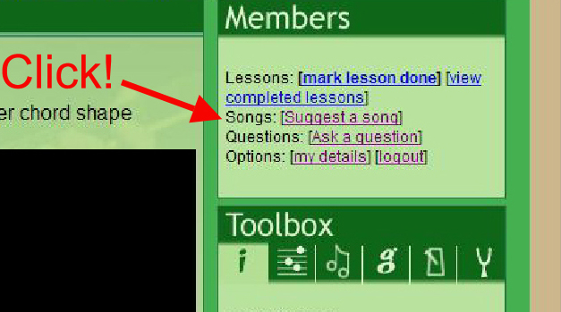

And at any time if you have any questions about learning to play the guitar please don’t hesitate to ask.

OK! See you on the course!

================================================================

