1
5.0 Kicking Teenagers with power chords

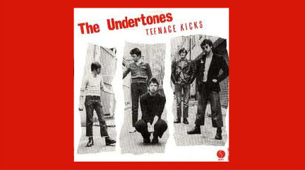
[Open with TnKxImage_16to9.jpg]

[Attach soundfile: SGT_IntroTeenageKicks.mp3]

[Nick head and shoulders]

- This song is something of a legend in the Music Industry.
- Written by the Undertones guitarist John O’Neil in 1977 at a time when the band were unknown outside their home town of Derry Northern Ireland.
- 1978 recorded a demo at local university and sent it to a host of record companies and got a load of rejection slips back

2
- But they also sent one to Radio One DJ John Peel who famously described it as ‘His all time favourite song’.
- Putting his money where his mouth was Peel funded a recording session in Belfast where the song was produced on a budget of just £200

- After an appearance on Top Of The Pops and with much support from the influential John Peel, the song broke into the UK charts and made it to number 31.

The great thing about it from our point of view is that it is a very easy song to learn for beginners and great fun to play!

Here’s the tab for the intro:
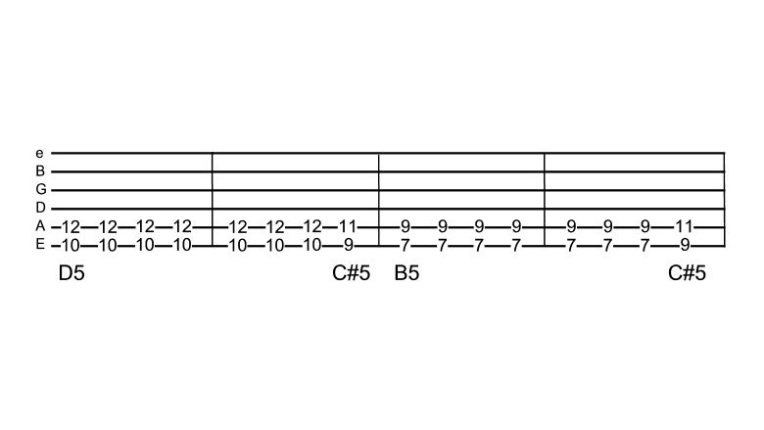
[Cut to TnKxTab_1_16to9.jpg]
3
You can see that it uses nothing but basic power chord shapes. We are going to learn it here with the two-note shape. (You can also play it with 3-note shapes if you prefer):

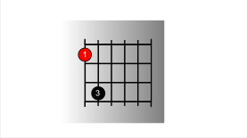
[Cut to Left hand with TnKx_5_16to9.jpg as PIP]

Which we hold down here at fret 10 to make a D5th chord.

Demo
[Cut to Nick Plus Guitar]
For now we are going to be concentrating on the fretting hand so we’ll simplify the rhythm to one hit per beat just like on the TAB
[Cut to Left hand with TnKxTab_1_16to9.jpg as PIP]
So we hit that chord four times for the first bar then on the last beat of the second bar take it down one fret to C#5
4
Demo (first two bars)
And keep moving down two frets this time to B5th at fret 7
Demo (first three bars)
Where we again play out two bars except for the last beat which works back up the fretboard to fret 9 to play the C#5 once before looping back to the start.
Demo (whole intro)

[Nick head and shoulders]
So that’s the intro. Practice that until its easy and then we’ll move on to the verse.
[Cut to TnKxTab_1_16to9.jpg]

The first line of the verse is actually exactly the same as the intro.

5
[Cut to Nick Plus Guitar]
Demo (with Vx)

Then we repeat it except for the very last beat of the fourth bar
[Cut to TnKxTab_2_16to9.jpg]
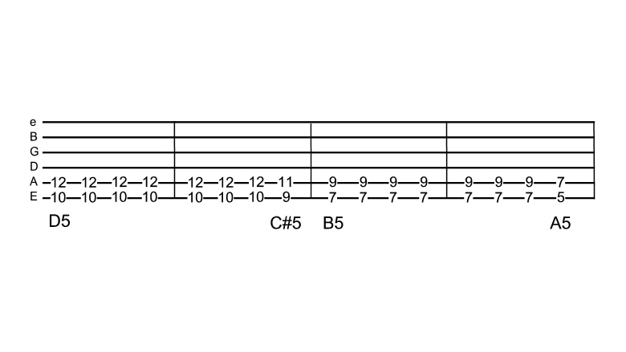

Where we move the shape down the fretboard to the 5th fret instead of back up to the 9th

[Cut to Left Hand with TnKxTab_2_16to9.jpg as PIP]
Demo

[Cut to Nick Plus Guitar]
This neatly links to the next part which is played at the third fret giving us a G5 chord

[Cut to TnKxTab_3_16to9.jpg]
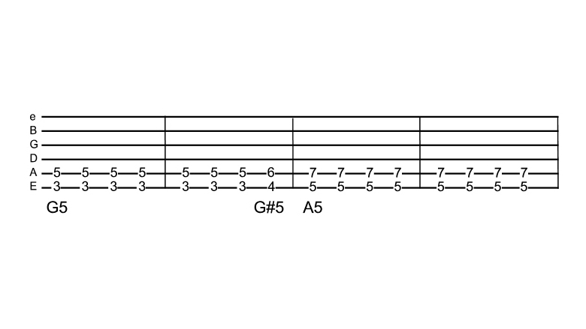
6
[Cut to Left Hand with TnKxTab_3_16to9.jpg as PIP]
Demo
Once again using a link on the last beat of the second bar moving the shape back up to the fourth fret (G#5) for one hit before playing 2 bars of (A5)at the 5th fret

[Cut to Left Hand with TnKxTab_3_16to9.jpg as PIP]
Demo
[Cut to Nick Plus Guitar]
The sequence then loops back and repeats exactly the same for verse two.

At the end of verse two there is an eight bar instrumental which is played over the chords of the intro. There is one small refinement which more experienced guitarists can add here if you like, but if you are a beginner, feel free to just play it same as the intro.

The refinement is a sus4 chord played on the 3rd beat of the second bar followed by a major shape on the fourth beat. This effectively replaces the C#5 link that we used on the original intro..
7
[Cut to Left Hand]
Demo (Explain)
It does the same on the repeat as well.

[Cut to Nick Plus Guitar]
Then we are back into a repeat of verse 1 and 2 followed by a guitar solo that is played over the first eight bars of the verse. Maybe we’ll look at the solo in a later lesson.

Finally the vocals come back in for the last four bars of the verse, then we finish with the ending

[Cut to TnKxTab_4_16to9.jpg]
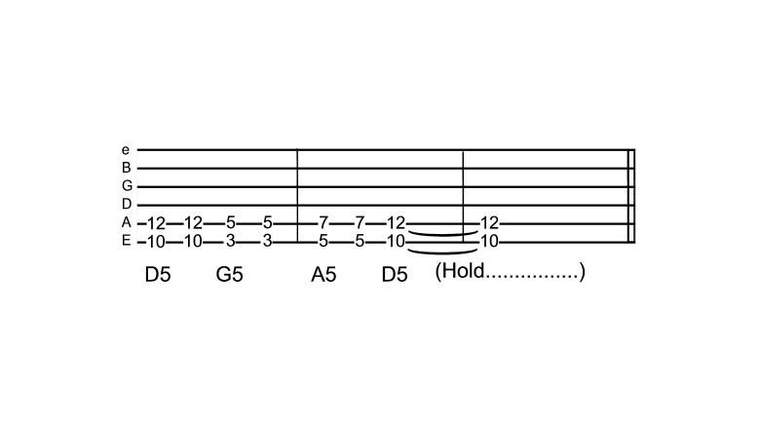
[Cut to Left Hand with TnKxTab_4_16to9.jpg as PIP]

Demo (Explain)

8
[Cut to Nick Plus Guitar]
A word about the strumming pattern. If you listen to the song you can hear that in true punk rock tradition the rhythm is not exactly constant and neither is the tempo. So rather than suggest a specific strumming pattern I want to encourage you to feel your way through the song. This is probably best done by playing along with the record.

Demo (Explain)

[Nick head and shoulders]
Okay, have loads of fun with that one and we’ll see you again soon in the next lesson.

================================

