1
0.8 How to Learn Chord shapes
[Nick plus guitar]

Guitar Skills divide into rhythm and lead
Demo
Lead - mainly notes
Rhythm - mainly chords
This lesson is about chords

What is a chord?
Define. Learning shapes
Demo
That’s what this lesson is about

4 commonly used ways to show chord shapes

[Cut to 16to9_chorddiag1.jpg]
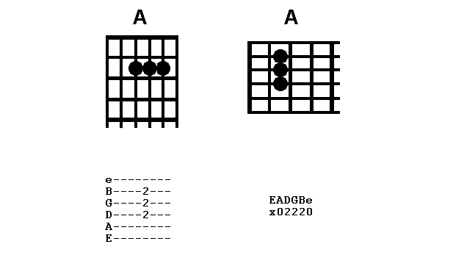

2
Each method shows the same thing –
Where to place your fingers on the fret board.
There are a minimum of two bits of information you need – which string and which fret number.

Look at how each method does this
[Cut to 16to9_chorddiag2.jpg]
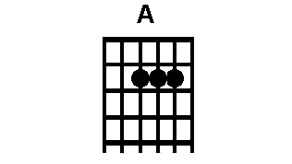

Here’s chord box or grid.
Six vertical lines – strings.
The horizontal lines are the frets.
The blobs show fingers.

Let’s show you how I interpret this:

[Suitable Transition to Nick Plus Guitar plus PIP 16to9_chorddiag2.jpg in top LH corner]
3
If I hold my guitar out in front like this
Then this (turn guitar to camera) is my
View of fretboard.
It’s this view that the diagram represents.

[Cut to16to9_chorddiag2.jpg]

So line on left = 6th string/Bottom E

[Cut to Nick LH keep PIP of 16to9_chorddiag2.jpg in top LH corner]

Diagram tells to put a finger behind the second fret on the D string
Demo…
Another finger at the same fret on the G string Demo… and again at the same fret on the B string.

[Cut to Nick plus guitar]

Of course, once you have got hang of this
You just see the shape and recreate it with fingers.

4
Sometimes extra info like numbers for fingers:

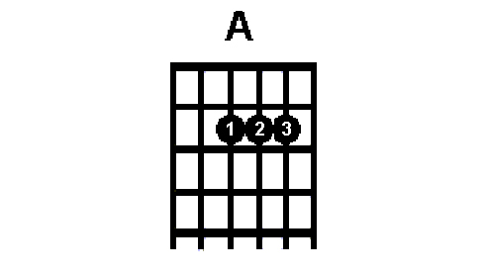
[Cut to16to9_chorddiag6.jpg]

… and symbols placed along the top of each string to indicate whether it should be sounded..(0)..
[Cut to16to9_chorddiag7.jpg]
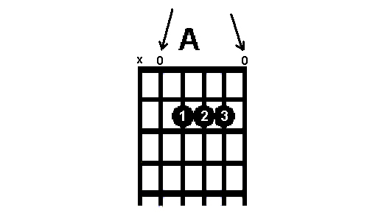
or not (x)
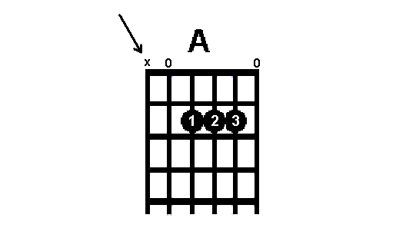
[Cut to16to9_chorddiag8.jpg]

5
[Cut to Nick plus guitar]
Hold down a chord play it to test
If it sounds ok it is
If not – the most likely possibility is
Right shape at wrong fret position:
[Cut to Left hand]
Demo
Or right shape on wrong strings
Demo

[Cut to Nick Head and Shoulders]
Now we’ll be using this method on this site
But there are others used in books and on
The web

Sometimes you’ll see grid presented Horizontally:
[Cut to16to9_chorddiag3.jpg]
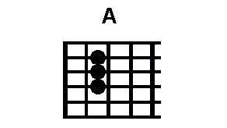
This can cause confusion trick is to look
Straight at your fretboard:

6
[Cut to Nick plus guitar with PIP of 16to9_chorddiag3.jpg top LH corner]
Demo to camera
With the nut to the left the 6th string is at the bottom so that helps you read it

On Internet tab sites you’ll see chords tabbed like this:
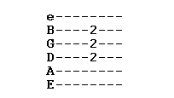
[Cut to16to9_chorddiag4.jpg]

Pretty much same view as horizontal grid

And sometimes you’ll just get a sort of set of co-ordinates like this:

[Cut to16to9_chorddiag5.jpg]
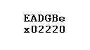
The ‘x’ says don’t play the E string
The 0 says play the A string open
The 2 under the D says play the D string at fret 2 and so on….
7
[Cut to Nick Head and Shoulders]

As long as you remember that each of these methods is just telling you where to place fingers on strings at frets – you’ll unravel them.

So, with this lesson under your belt you should be able to learn a whole load of chords.

But learning chords only takes a few minutes.

Learning to CHAnGE takes typically months of practice so that’s where we’ll be heading next….

================================================================

